The Islamia University of Bahawalpur
Department of Information Technology
Faculty of Computing


SOFTWARE DESIGN DOCUMENT (SDD)
for
<Smart pet clinic>
Version 1.0

By
Student Name: Ali Waris
Roll No: BINFT1M01161
Section: 7th M(5)
Session: Fall 2022-2026
Supervisor: Mam Sara fareed

Smart Pet Clinic

Software Design Document
Version:1.0

Prepared By:
Ali Waris

Acknowledgement

The Islamia University of Bahawalpur. She has been a constant source of guidance throughout the course of this project. We would also like to thank Mam Sara fareed for her help and guidance throughout this project. We are also thankful to our friends and families whose silent support led us to complete our project.

1. Ali Waris

Date: Jan 10,2026

Revision History

Date | Description | Author | Comments
<date> | <Version 1> | <Your Name> | <First Revision>

Document Approval

The following Software Requirements Specification has been accepted and approved by the following:
Signature | Printed Name | Title | Date
 | <Your Name> | Lead Software Eng.

Chapter 1: Introduction

Advent
This project is designed to provide automatic and easy way for making appointments to veterinary doctors, online treatments and dealing with emergency situations. Normally people first must find hospitals, then they visit them and then apply for appointment that has a long procedure. On the day of check-up, they again visit hospital. Also, sometimes the doctor may be absent. But they come to visit the doctor as per their appointment day. This may waste someone’s precious time. For emergency; people must find contacts for hospitals and ambulance at that critical situation. There may be no doctor available in a hospital near to them for their pets, if ambulance take them to that hospital, it endangers the lives, also the patient can buy accessories and food for the pets To overcome these problems, this project is designed and developed that ensures the security of lives by automating system in emergency case and to reduce the unnecessary visits to hospitals and doctors.

Motive
- Smart Pet Clinic is for all the problems and for all the people as well. You don't need to go to hospital for small issues. You just have to inform your doctor by sending videos and doctor will respond you either in case of assigned prescription or home remedy. Every person doesn't have the know-how about the usage. So by this project, you can interact with your doctor by chatting in any language easily Stay Safe, Live Long.
- Auto Response
- Emergency handler
- Emergency request

Project Scope
Smart Pet Clinic Web app is to bring the manual reception system of appointments up to technological modernity. The user will no longer need to visit and search hospitals and their specialist doctors. He can find in one platform. They will get a secure platform that they can trust and get help in case of emergency and the accessories and food of the pets will be available to buy online.

The smart system, following operations will be performed:

- 1 | Online appointments will be made on request by user and acceptation by doctor.
- 2 | User will be able to view and request differ payment doctors of multiple hospitals (registered).  The record of the pets and doctor consultation will be saved to remind the history of pet health.
- 3 | It will be ensured that the user cannot request for more than one appointment at the same time. If he does by himself many times, he will be declared as “Fake user”.
- 4 | If the Doctor is absent, all of his appointments will be canceled, and notification will be sent to all of his patients.
- 5 | The user of the system will be able to buy food and accessories online (FAO).
- 6 | Patient and Doctor will be able to communicate with each other online by chat, if the check-up doesn’t take so long.

Definitions, Acronyms, and Abbreviations
FAO ---- Food and accessories
GUI ---- Graphical User Interface
SRS ---- Software requirements specification
SQL ---- Structured Query Language
SPC ---- Smart Pet Clinic
LDR ---- Logical Database requirements
ER ---- Emergency Request

Chapter 2: Design Document

2.1. Introduction:

Third deliverable is all about the software design. So, we understand the current situation of the problem domain. Now, we are ready to strive for a solution for the problem domain by using object-oriented approach.

- Domain Model
- System Sequence Diagram
- Sequence Diagram
- Collaboration Diagram
- Design Class Diagram
- State Transition Diagram
- Data Model
- ER-Diagram

Domain Model

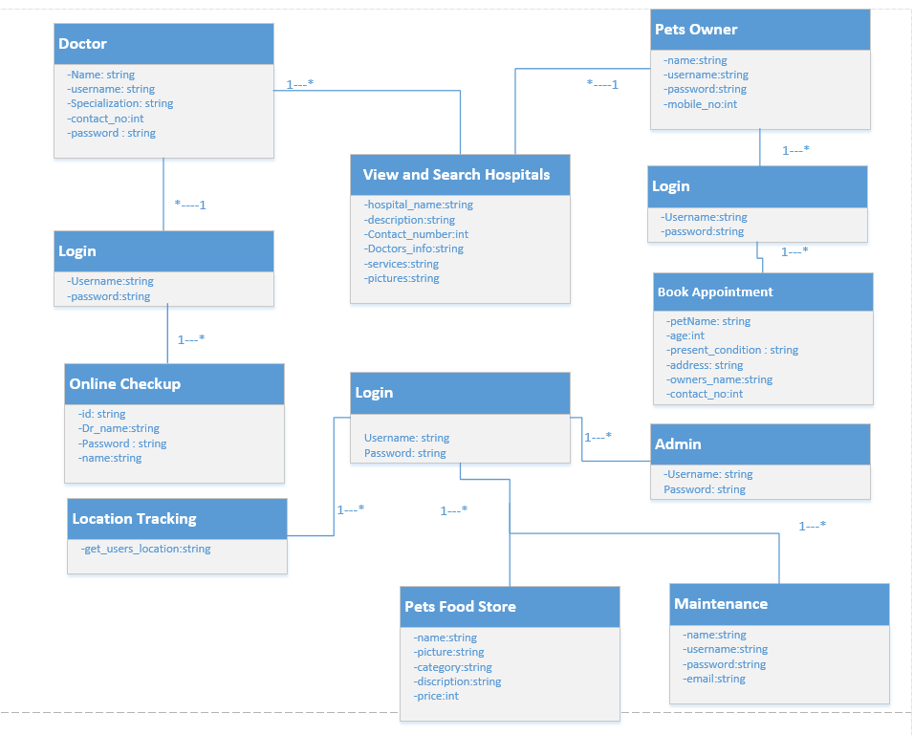

2.3 User Sequence Diagram

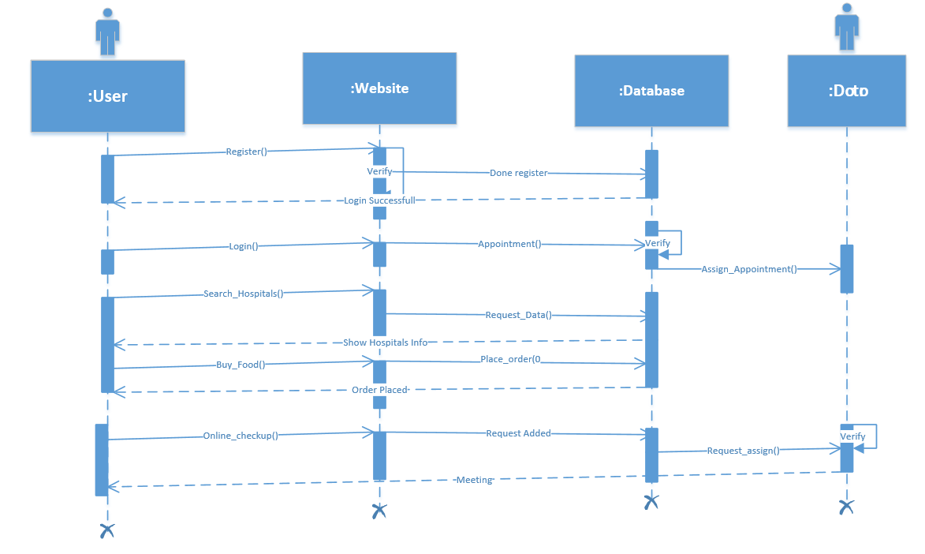

2.4 Doctor Sequence Diagram
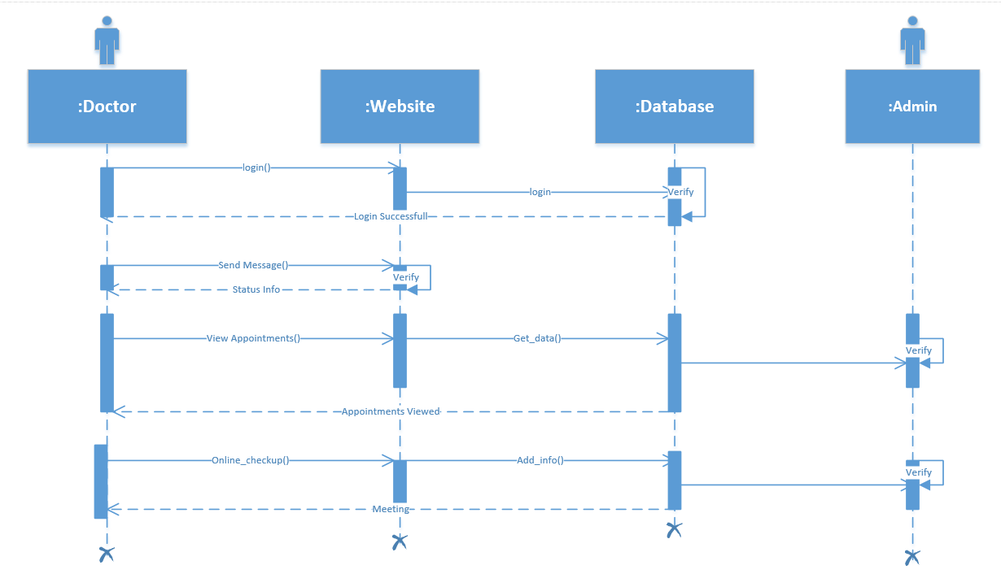

Admin Sequence Diagram:

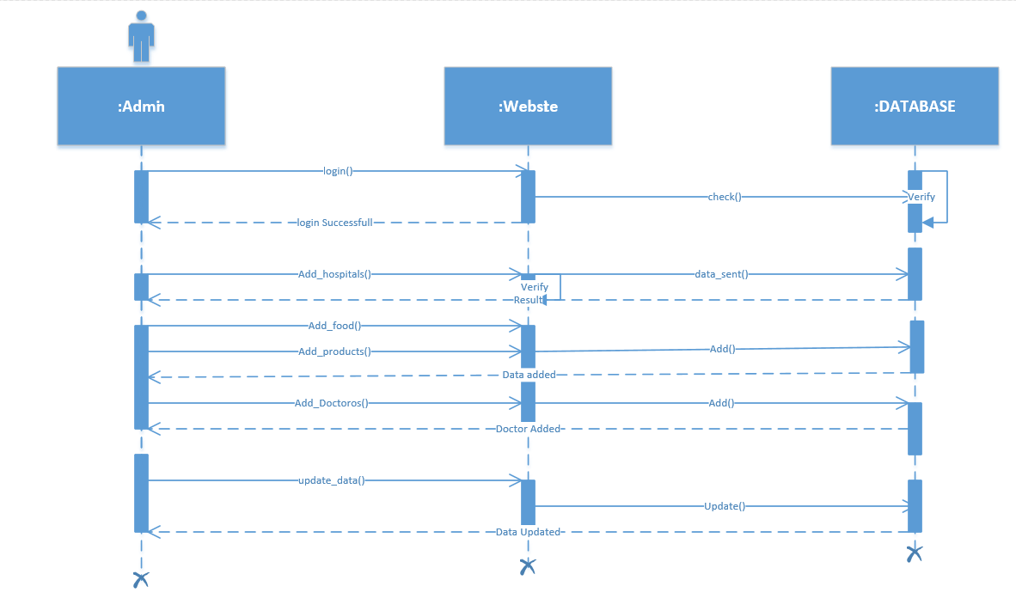

2.5 Collaboration Diagram

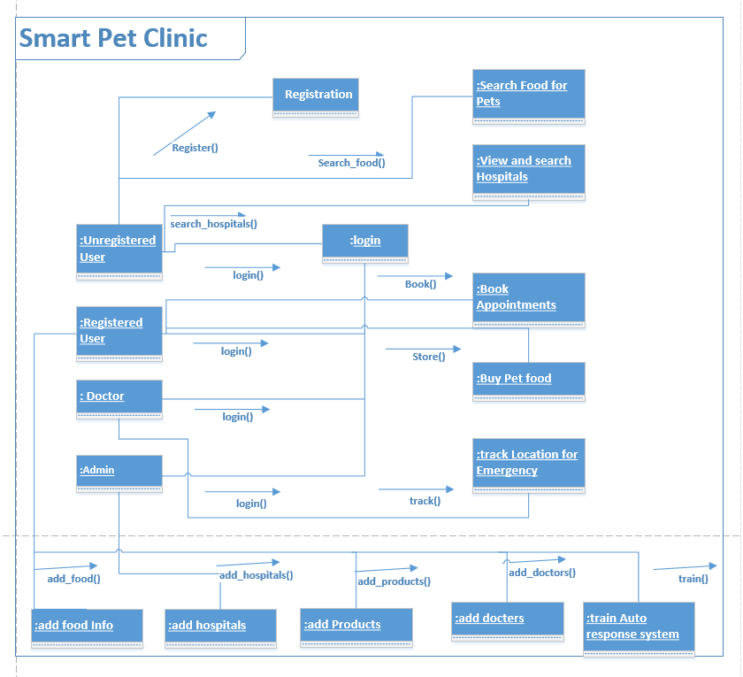

2.6 Design Class Diagram

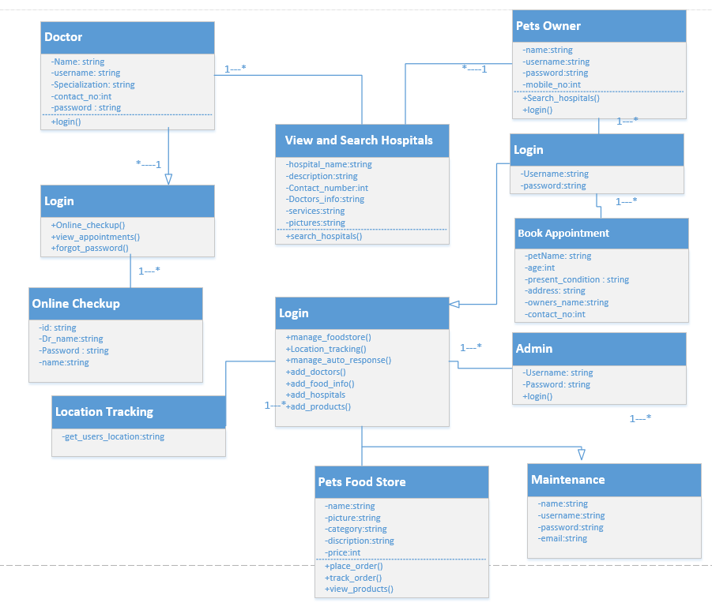

  - State Chart Diagram
- User
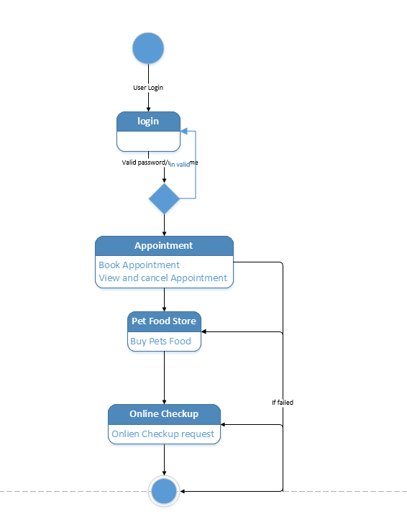

- Doctor

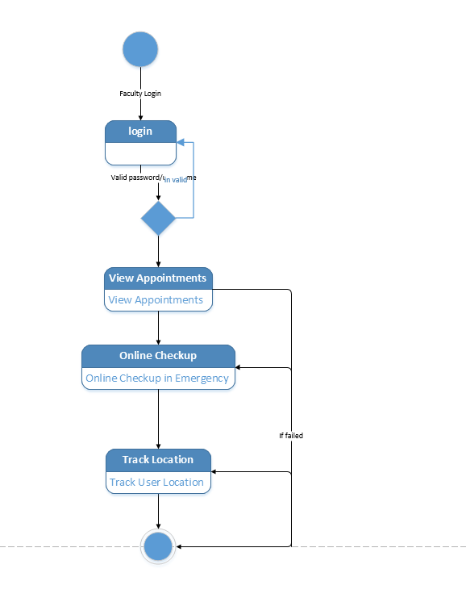

- Admin

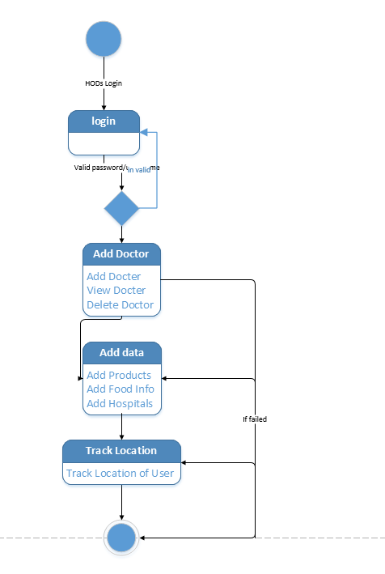

Data Model Diagram
The data model is a subset of the implementation model, which describes the logical and physical representation of data in the system.

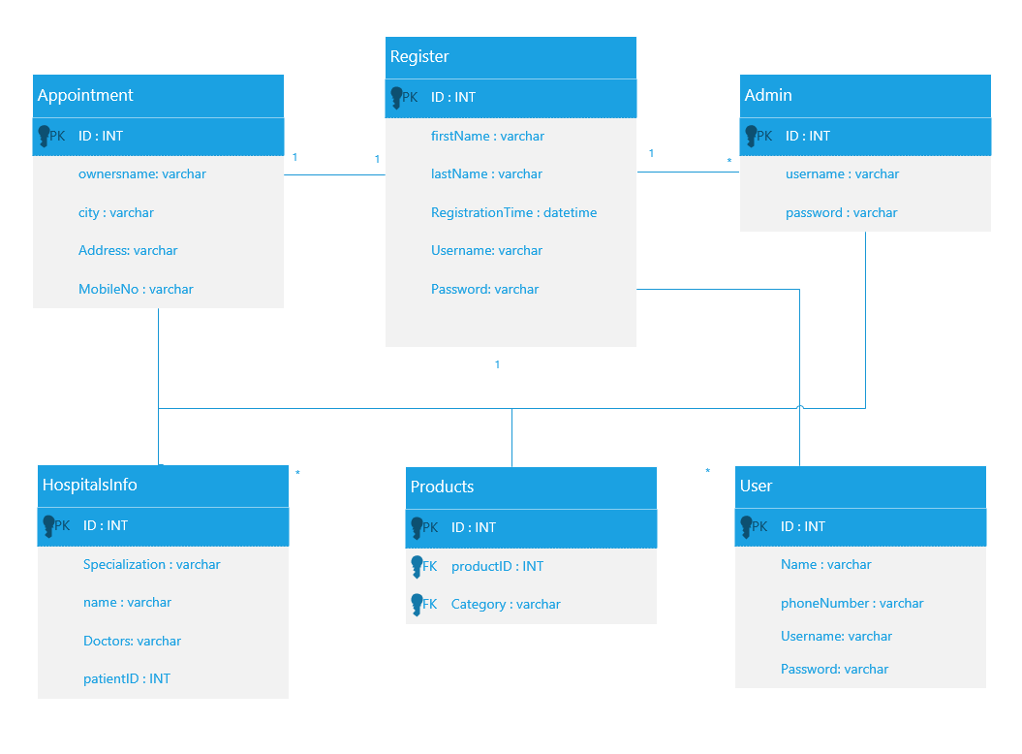

2.9 ER Diagram
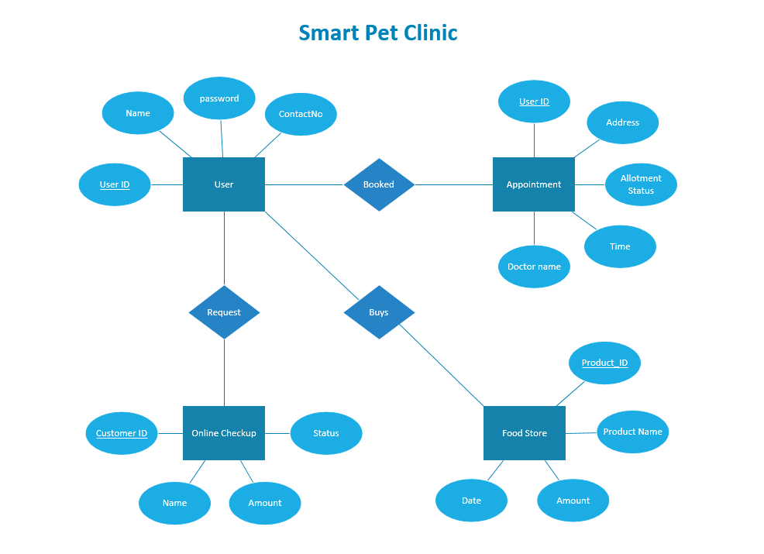

Chapter 3: User Interface Design

3.1. Introduction
A user interface design consists of two main parts:
- Site maps
- Storyboards

3.2. Site Maps
Homepage
Login
Pet Food Info
Pet Food Store
Sign up
Sign in
Search Hospitals and Book Appointments
Emergency request
Appointment
Book Appointment
Register
Chatbot
Add Pet Info
Request for Online Check-up
View appointment
Ask Questions
Get response
Use Voice Functionality
Emergency Info through Auto Response System
Cancel appointment

Admin
Login
Add Doctors
Chatbot
Add Doctors
Assign Appointments
View appointment
Add Questions
Set Questions
Manage data
Add Products into Store
Manage Orders

3.3 Story board:
A storyboard is a sequence of single images, each of which represents a distinct event or narrative. It is also a visual representation of the script illustrating the interaction between the user and the machine. It can also be imagined as a film in visual-outline form.
A storyboard can be used in two ways. It describes the task, which are a series of images showing the user, environment and the machine. It also describes the interface, which represent series of screen images indicating the user’s representation and the computer’s response and work out interaction details. It also shows interaction sequence at a glance and helps develop usage scenarios to help develop tools & tasks. Following is the view of login to be used for authentication of the product:

Website:

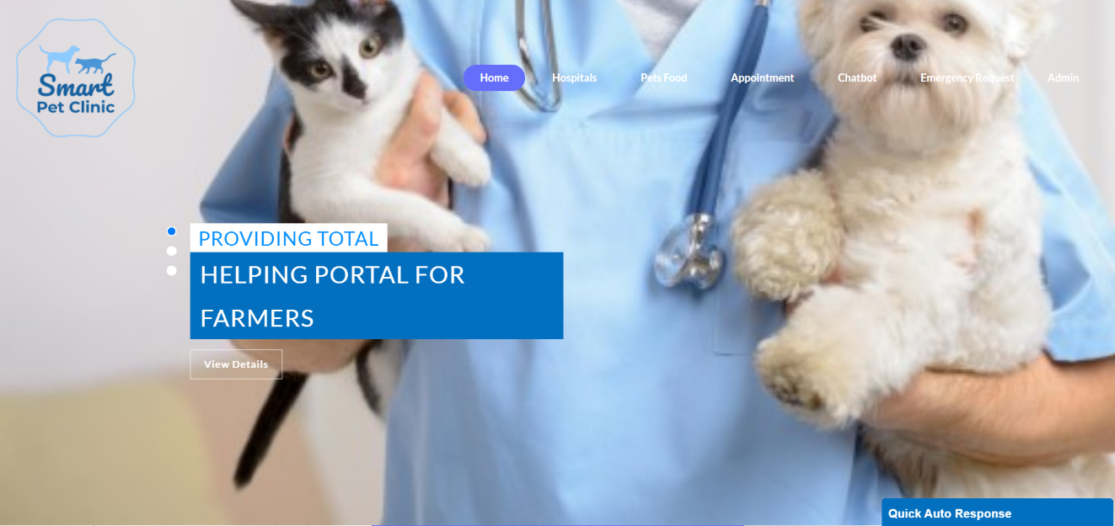

Register:
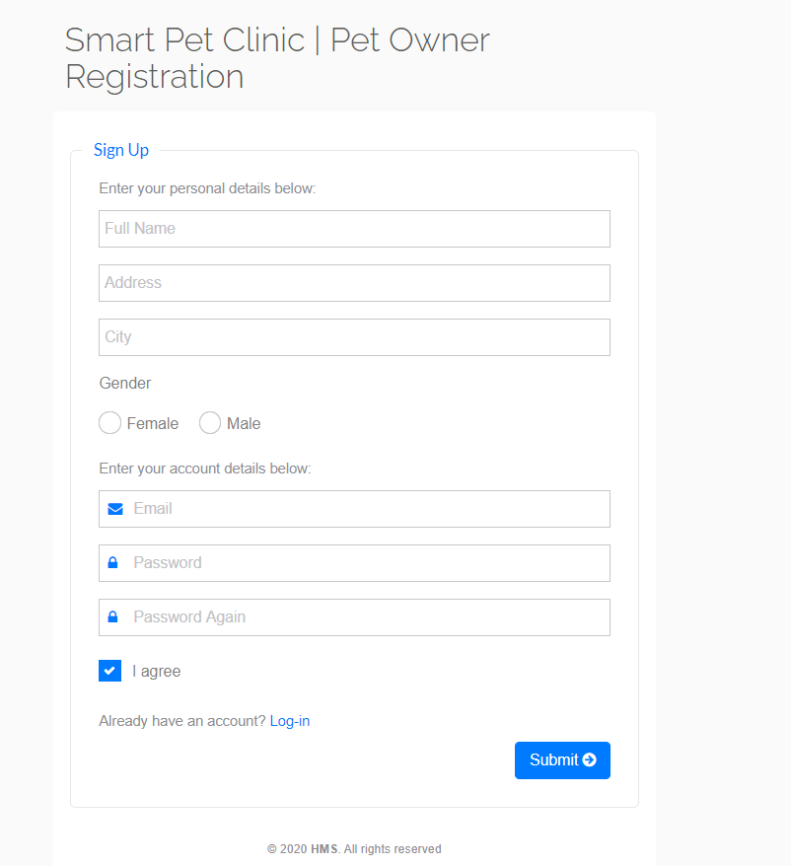

Login:
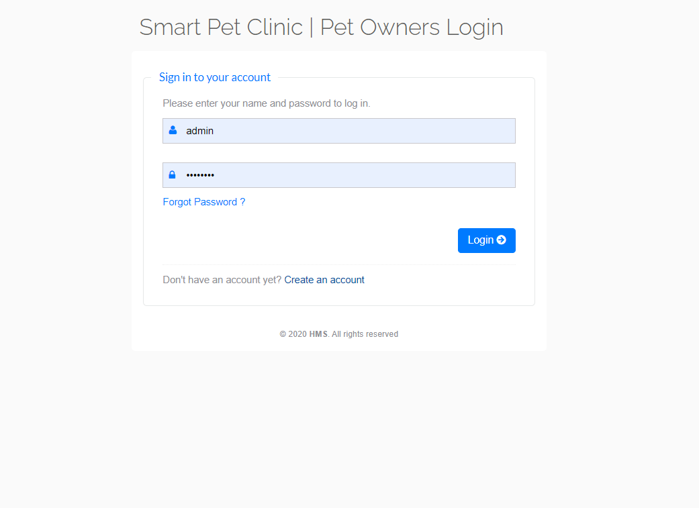

Location Tracker:

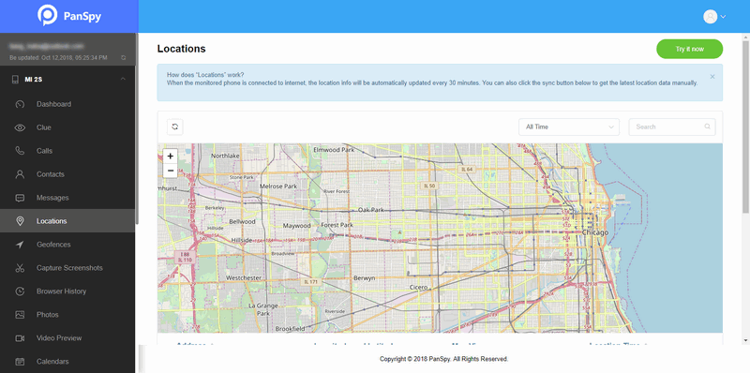

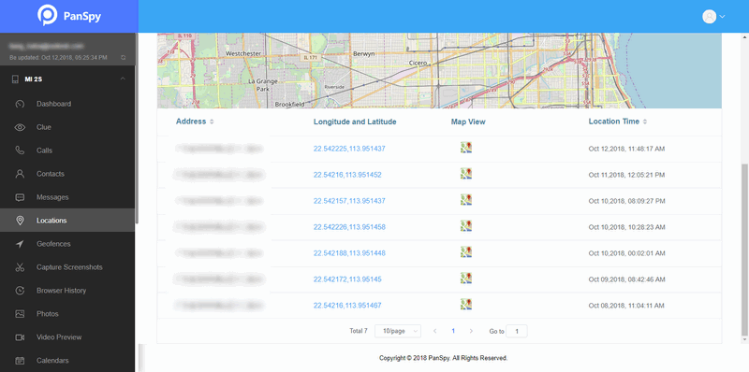

Emergency handler:

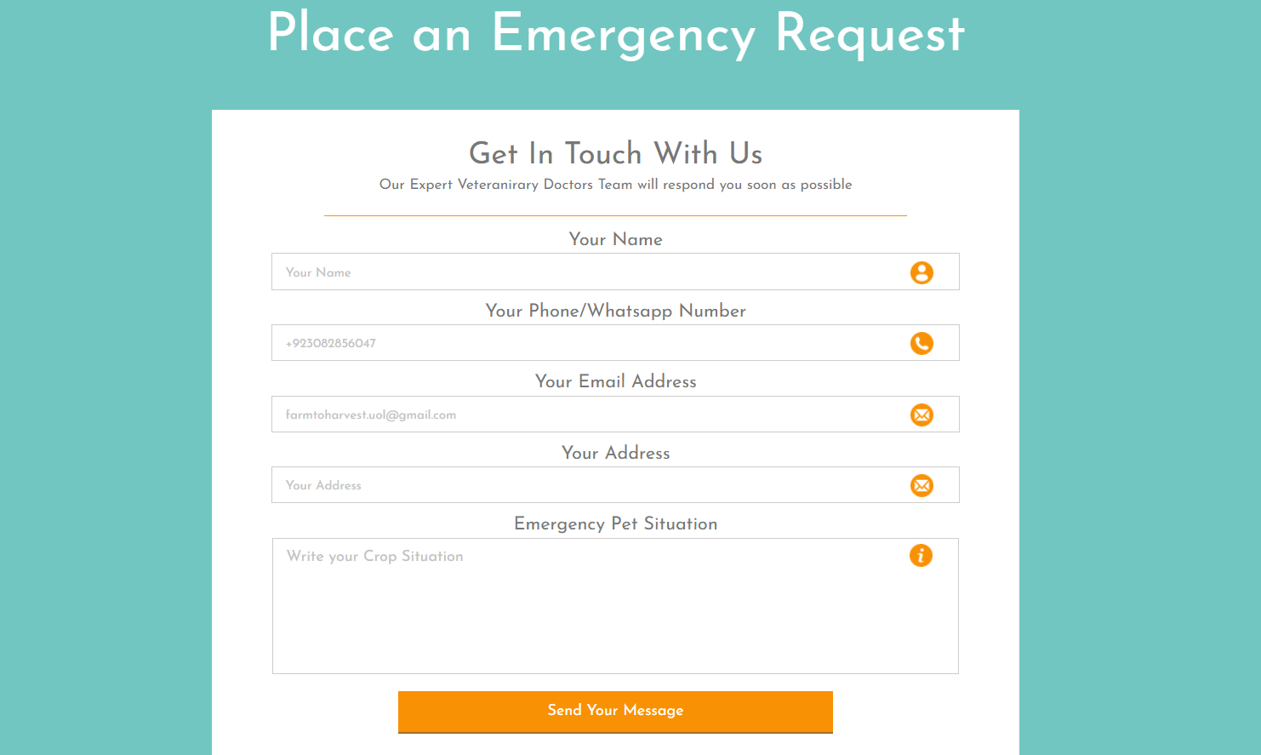

Appointment:
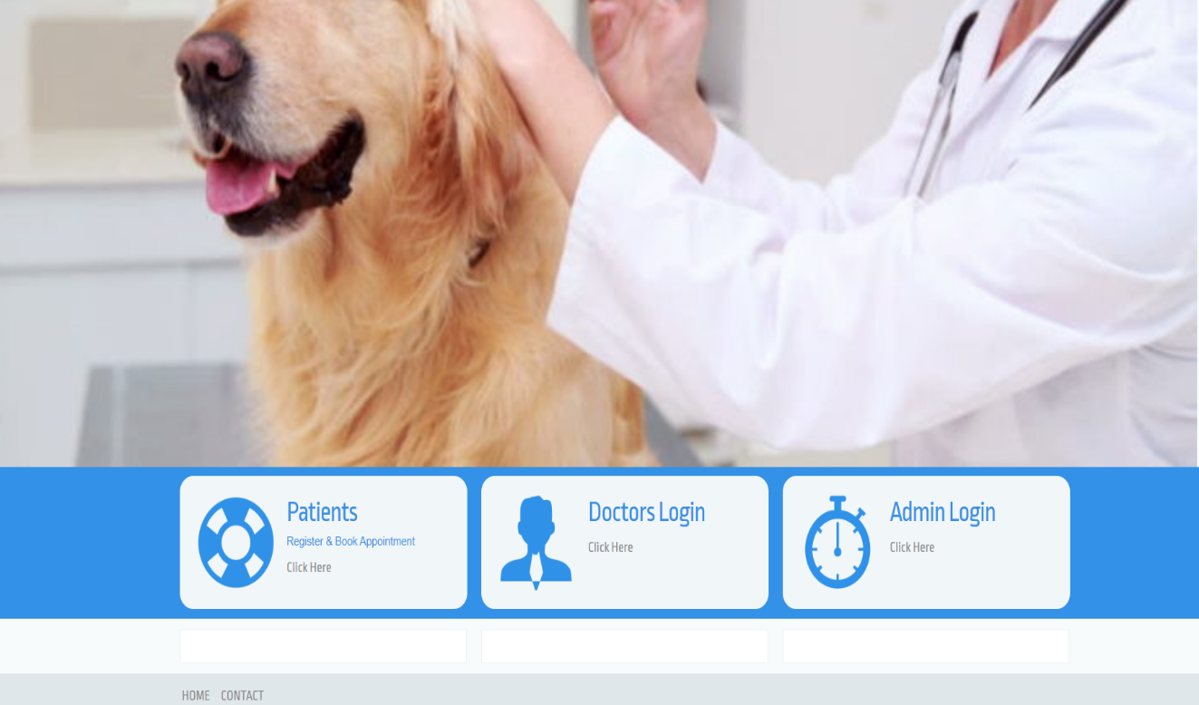

Docter Search:


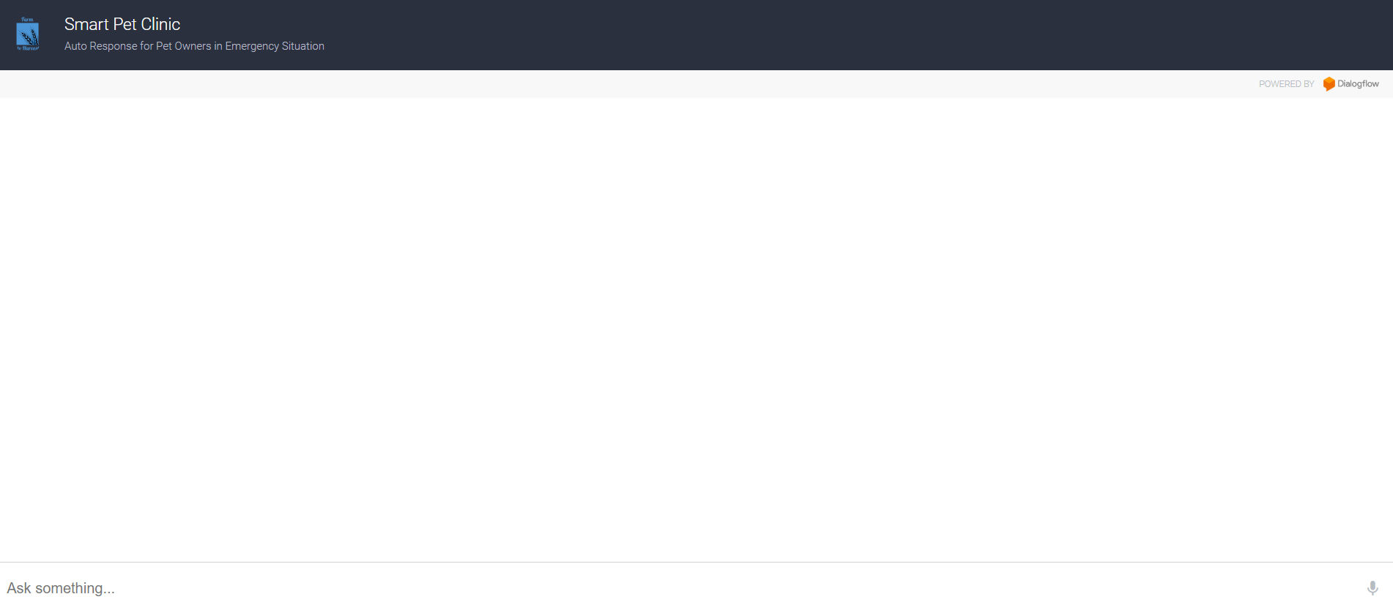

Administrator:
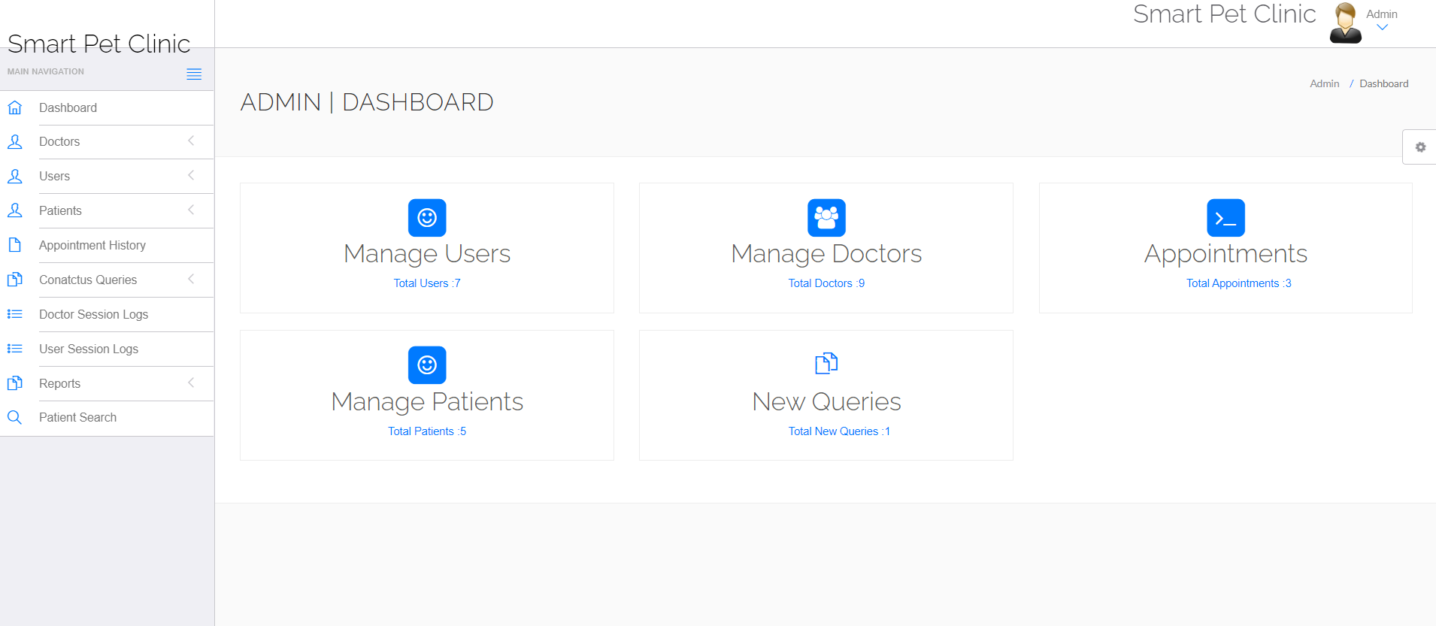

Food Store:

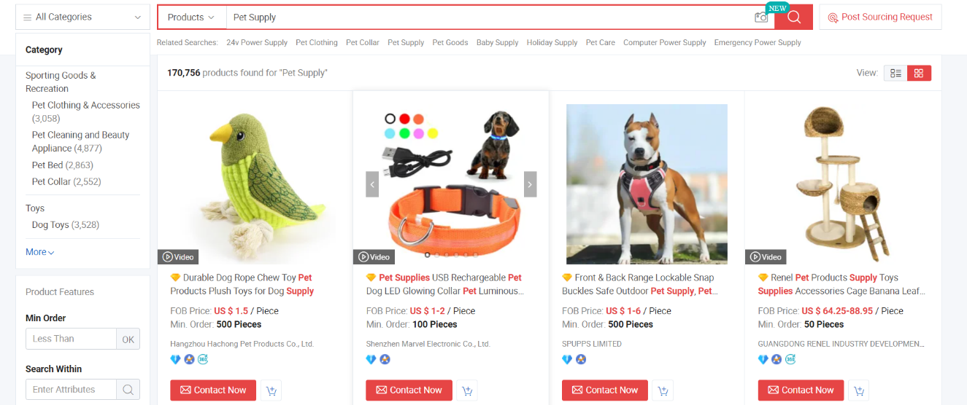

Chapter 4: Requirements

4.1 Environmental Needs
No specific needs are required for testing to be get performed. 64-bit Windows operating system and 8.00 GB RAM size will be used. Testing will be done using test cases and will be performed in software testing tool known as JIRA and also documented in this deliverable with certain conditions and pass/fail criteria.

Hardware
Notebook system will be used to perform the related testing. We will use 8.00 GB RAM size for execution of these test cases.

4.3 Software
We will use 64-bit Windows operating system. Moreover, testing will be done using test cases and will be performed in software testing tool known as JIRA and also documented in this deliverable with certain conditions and pass/fail criteria.

4.4 Other
There is no need of unique facility or trained personnel to perform this testing. A software tool is needed to perform all testing work and will be done by all three group members.

4.5 Special procedural requirements
We have no constraint when to perform testing related to our project.

Inter case dependencies
Following is the list of identifiers related to test cases that must be executed prior to this test case and summary of the nature of the dependencies:
- Registration before login.
- Logout after login.
- Registered before online Appointment.
- Login before Buying food and accessories.

Login: For Registered Users

ID | Test Case Name | Test Case Description | Pre-Conditions | Steps | Post-Conditions | Expected Results | Actual Results | Test Case Status
APF-01 | Login | User should be able to login to the system after authentication. | User must be registered and have an account before. | 1-Enter valid User-name.  2-Enter valid user password.  3-Click on login button. | Home page is displayed to the user. | User successfully logged in to the account. | Home page is displayed to the user when logged in to the account. | Pass

Login: For Un-Registered Users

ID | Test Case Name | Test Case Description | Pre-Conditions | Steps | Post-Conditions | Expected Results | Actual Results | Test Case Status
APF-02 | Login | User should not be able to log in to the account after entering invalid details. | None | 1-Enyer invalid Username.  2-Enter invalid user password.  3-Click on Login button. | Error message is displayed to the user. | Un-successful to login to the account. | Please enter the valid credentials. | Pass

Login: When anyone of the details is invalid

ID | Test Case Name | Test Case Description | Pre-Conditions | Steps | Post-Conditions | Expected Results | Actual Results | Test Case Status
APF-03 | Login | User should not be able to login to the account when anyone of the details is not correct. | None | 1-User enters invalid name,  OR  2-User enters invalid password.  User clicks on Login button. | Error message is displayed to the user. | Un-successful to login to the account. | Please enter the valid credentials. | Pass

Login: When anyone of the fields is empty:

ID | Test Case Name | Test Case Description | Pre-Conditions | Steps | Post-Conditions | Expected Results | Actual Results | Test Case Status
APF-04 | Login | User should not be able to login to the account when anyone of the fields left empty. | None | 1-User enters the name or leaves the field empty.  2-User enters the password or leaves the field empty.  3-User clicks on login button. | Error message is displayed. | Un-Successful to login to the account. | Please enter the valid details in empty fields. | Pass

Logout:

ID | Test Case Name | Test Case Description | Pre-Conditions | Steps | Post-Conditions | Expected Results | Actual Results | Test Case Status
APF-05 | Logout | User should be able to logout from the account. | User must login to the account. | 1-User clicks on logout button. | Login form is displayed on the screen. | Successfully logged out from the account. | Logged Out | Pass

ID | Test Case Name | Test Case Description | Pre-Conditions | Steps | Post-Conditions | Expected Results | Actual Results | Test Case Status
APF-06 | Registration | User should be able to register him/herself. | None | 1-User enters name.  2-User enters address.  3-User enters e-mail.  4-User enters password.  5-User clicks on OK button. | A report is generated confirming registration of the user. | Successful registration. | Registered Successfully. | Pass

Registration:

Online Order:

ID | Test Case Name | Test Case Description | Pre-Conditions | Steps | Post-Conditions | Expected Results | Actual Results | Test Case Status
APF-07 | Online Order | User should be able to place order online. | User must have an account. | 1-User enters all the necessary details required to place order online.  2-User clicks on OK button. | A report is generated confirming order placement and order status is updated. | Order placed Successfully. | Order placed. | Pass

Online Appointment:

ID | Test Case Name | Test Case Description | Pre-Conditions | Steps | Post-Conditions | Expected Results | Actual Results | Test Case Status
APF-09 | Online Appointment | User should be able to login to the system after authentication. | User must have an account | 1-User clicked on Appointment | None | Appointment Booked Successfully | Appointment Booked | Pass

